**#] Create a repo**

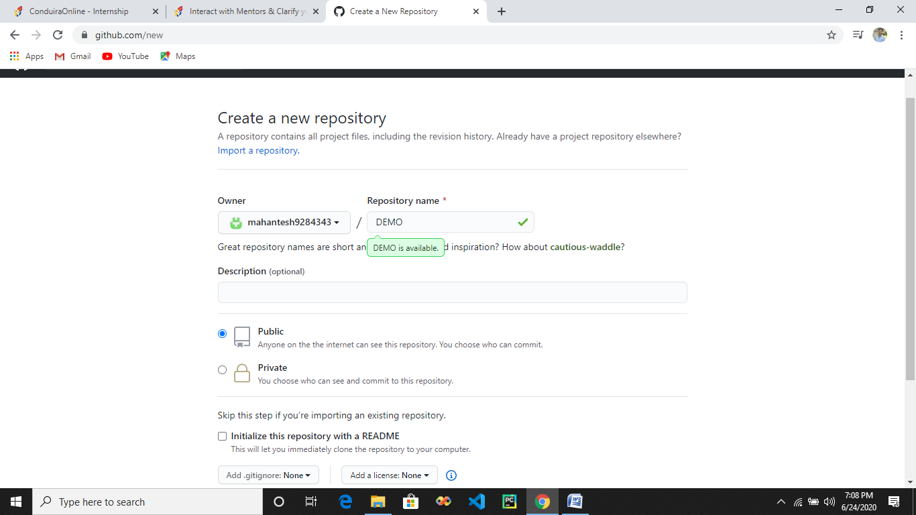

**#] Copy the repo ID**

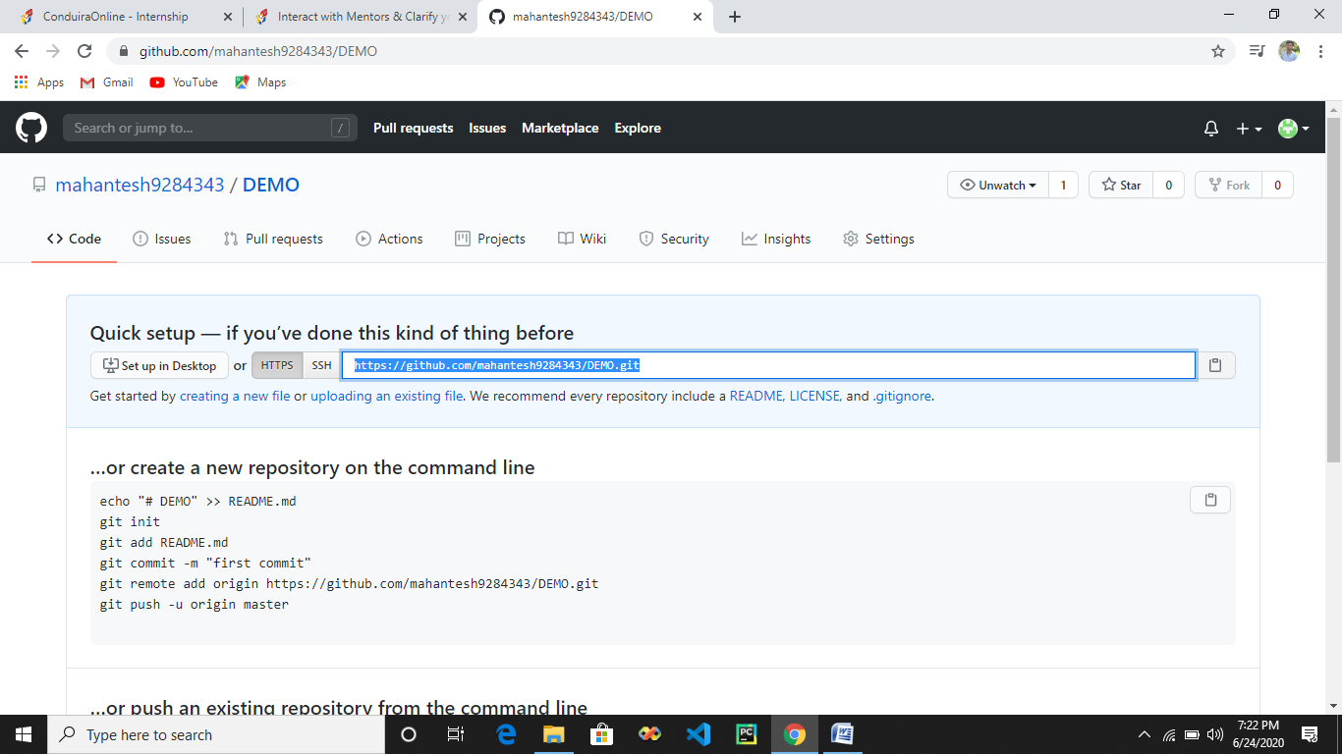

**#] Cloning the repo that is there on the github website into the local platform.**

* **mkdir - make directory**
* **cd – change directory**
* **clone : cloning repo DEMO into git in local platform**
* **ls : files and folders present in system**
* **git config : connect and add data to repo beteen git and github**
* **ls -la : folder should contain .git folder , if the folder does not contain .git it is not a github repo**

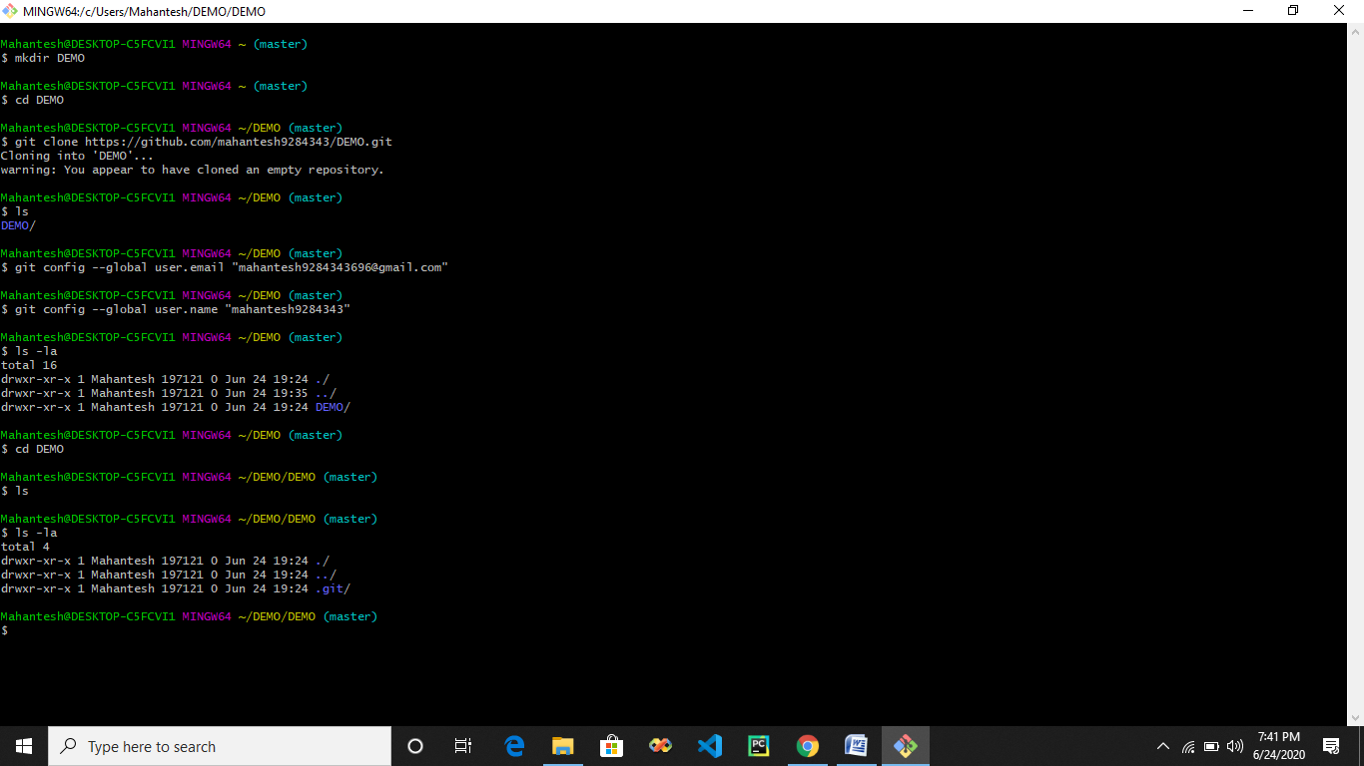

**#] How to add , commit and push.**

* **Code 1.html : will open code editor and allows us to write html code and save it which will be created in local machine.**

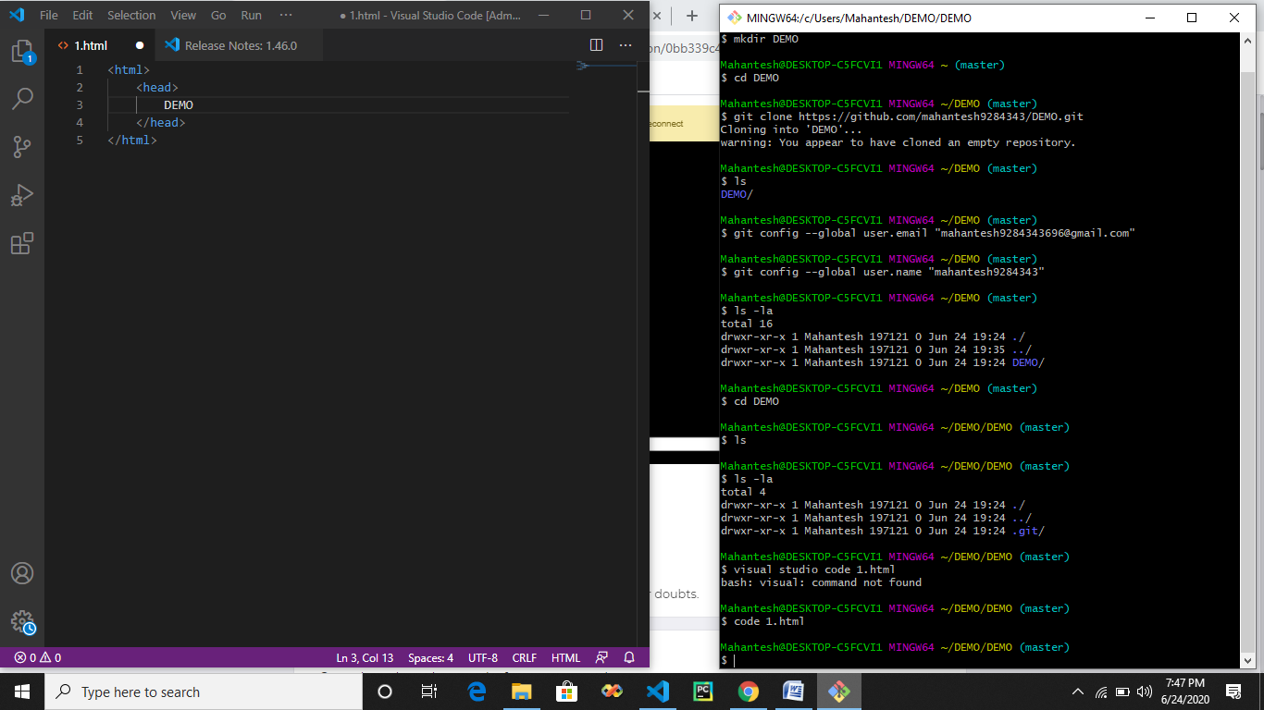

* **In the same way if we write command** 🡪 **notepad pro.py will create python file**
* **Same way we can create any kind of file c , c++ , java etc**

**Command is** 🡪 **editor_name file_name.(py,c,c++,js) any file you want**

* **ls : determine all files in local machine ie 1.html which we created is still on local machine**
* **Since we have configured github with git so now we have to get these 1.html into our github profile**
* **status : will show the github status , initially it will determine untracked files as we have not pushed any files on github and status will show 1.html which is present in local machine**

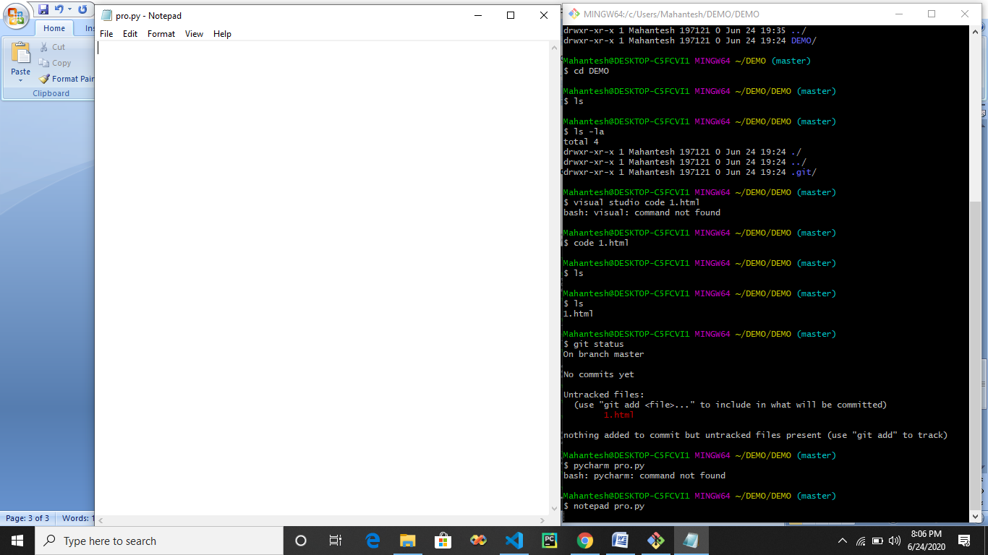

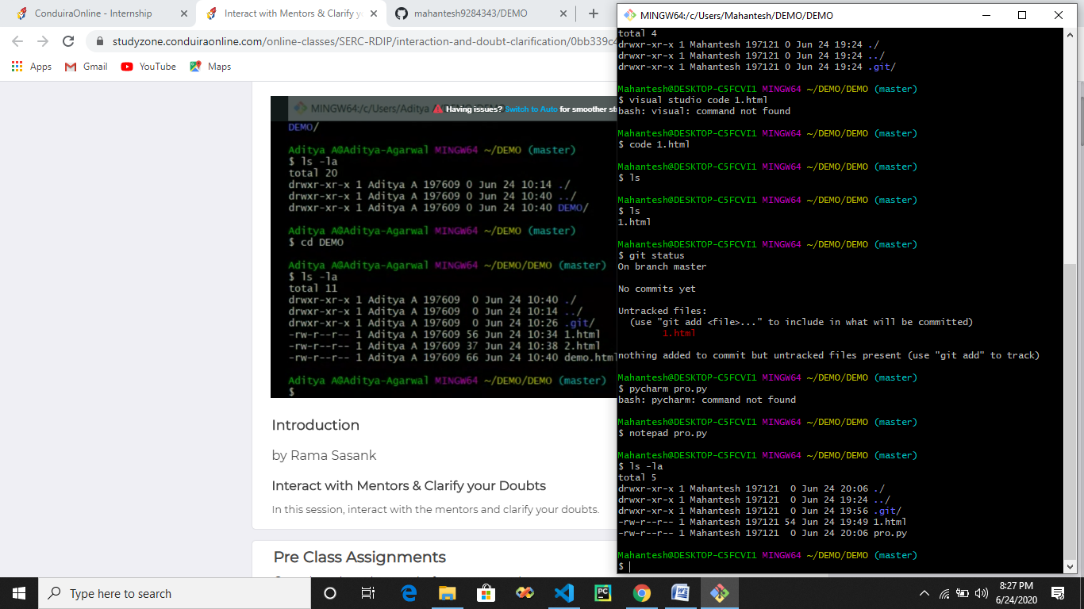

* **We can also create files externally and add it to folder in which .git folder is present.**

**I have add.txt on desktop which I need to put in folder which contains .git folder so that I can push it to github repo.**

* **Whichever files we need to push into github repo it has to be present in folder which contains .git folder**
* **Where we will find .git folder which we have we have to go in c**

**path :- drive 🡪 users 🡪 mahantesh 🡪 DEMO(which we have created using git bash)🡪DEMO(These DEMO is cloned repo from git)**

**since we have already created 2 files html and python file using git bash are also present in the DEMO folder**

**So now we have to copy ant file and put it into DEMO folder which als contain .git folder**

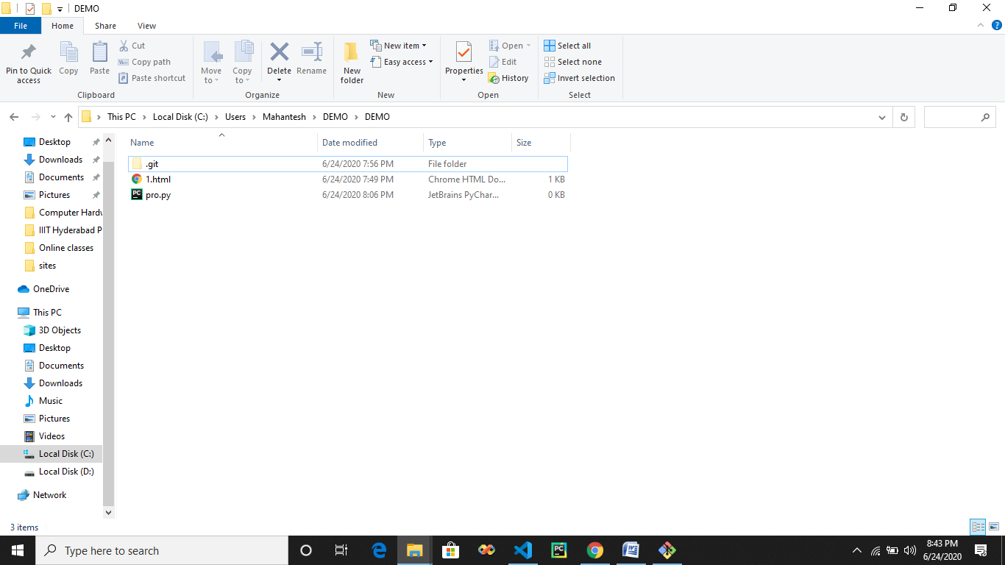

* **Here I can put any file and all the files here can be pushed into github repo.**
* **After adding a file add.txt(we can put any file)**

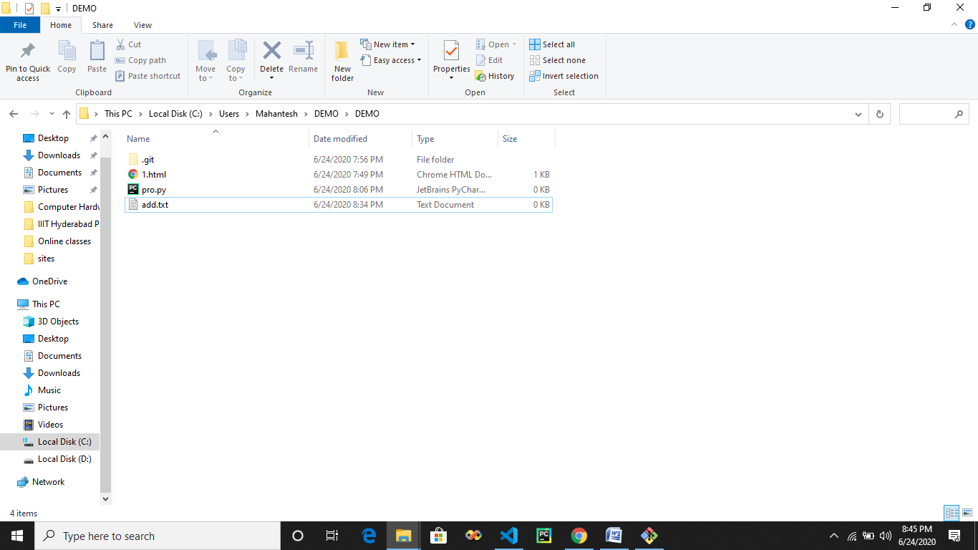

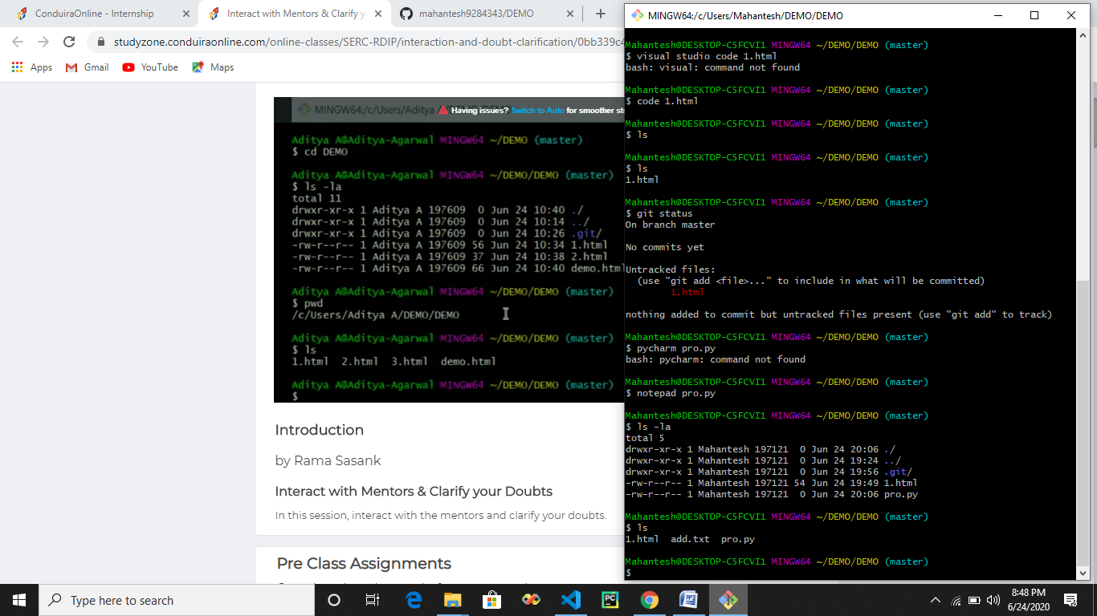

* **Here we can all files present in folder DEMO**

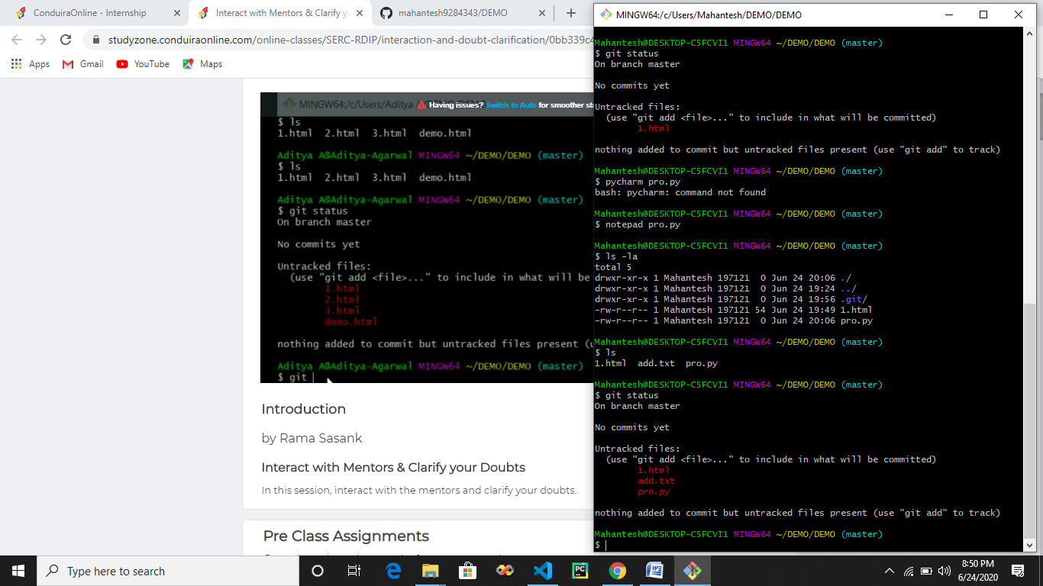

* **Always use git status to know what is happening in local directory**
* **Still showing untracked files because we haven’t pushd any files to our github repo**
* **The 3 files which are shown are present in local directory/machine.**

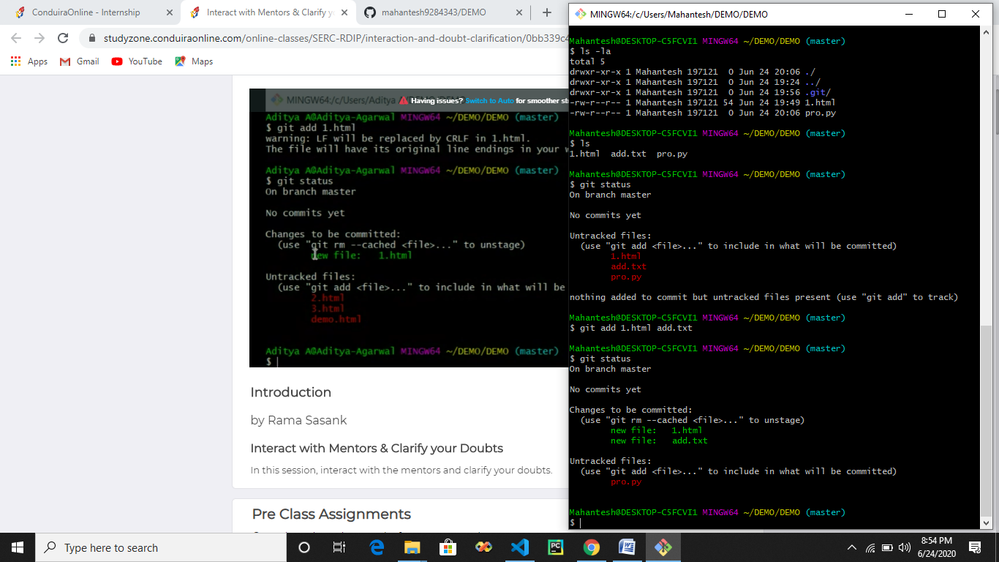

* **Now we can see that we have added 2 files which are turned into green but these files are added into working directory and not in github still.**
* **Still we push it we wont get it into our repo.**

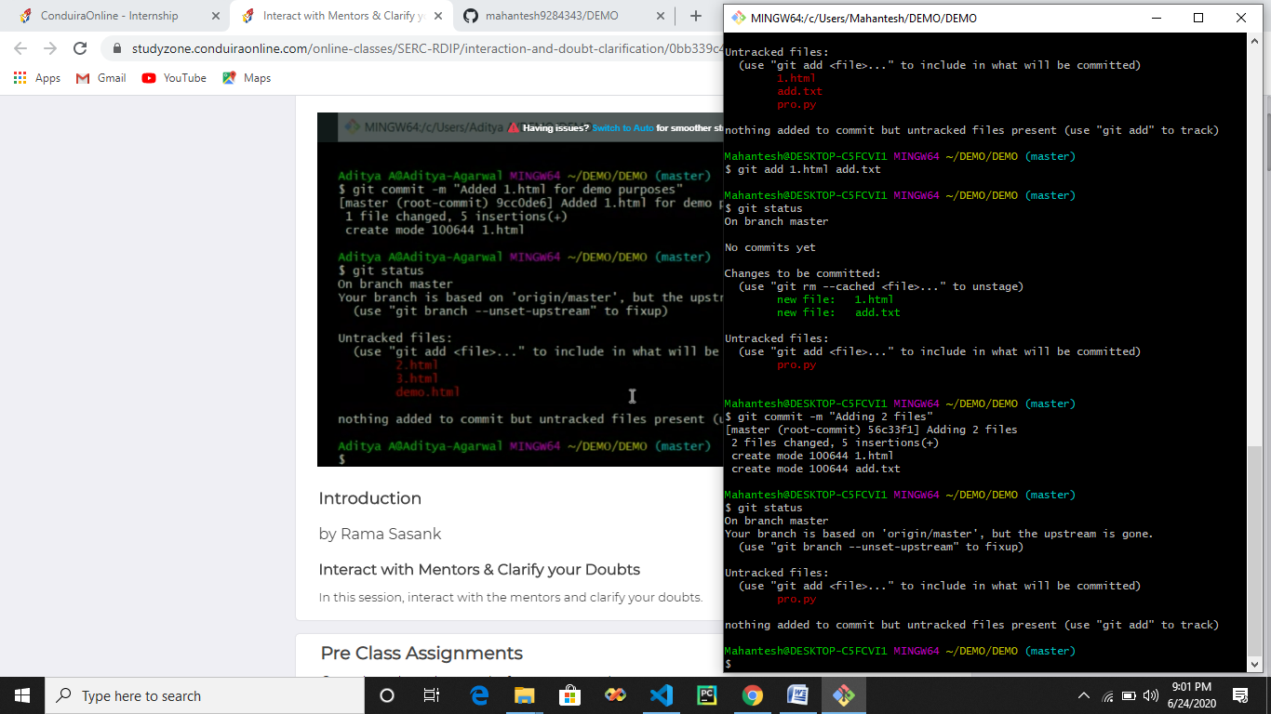

* **Here we can see that after commit files which are added are gone means files are ready to be transferred to repo , we now just have to push files into the repo.**
* **Git bash understood that we have added and commit the files.**

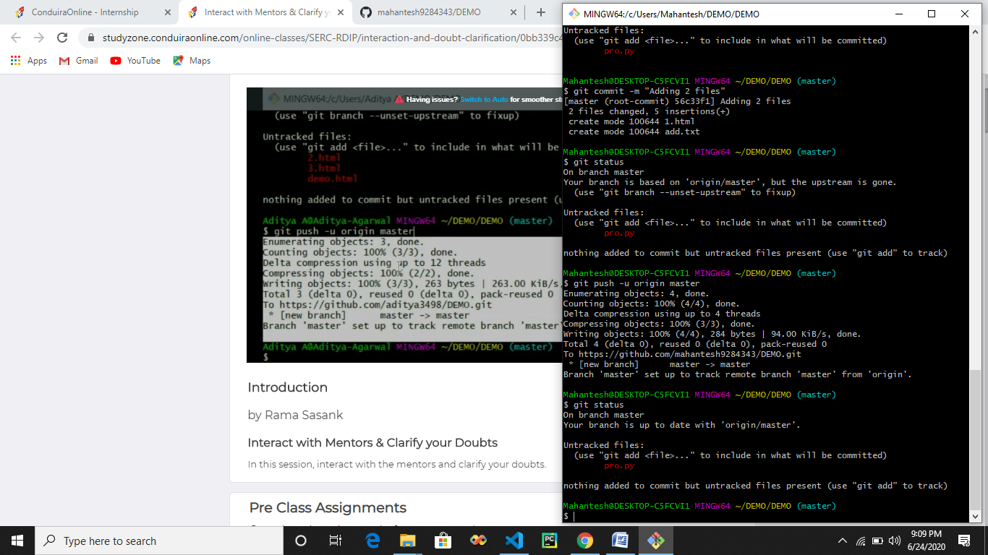

* **Her we can see that we have pushed a files from local repository to main repo.**

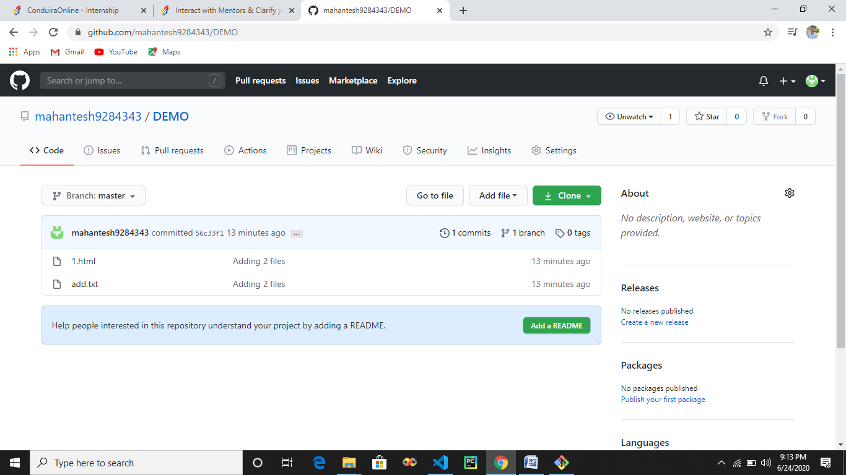

* **Here we can see that files are pushed into our main repo.**

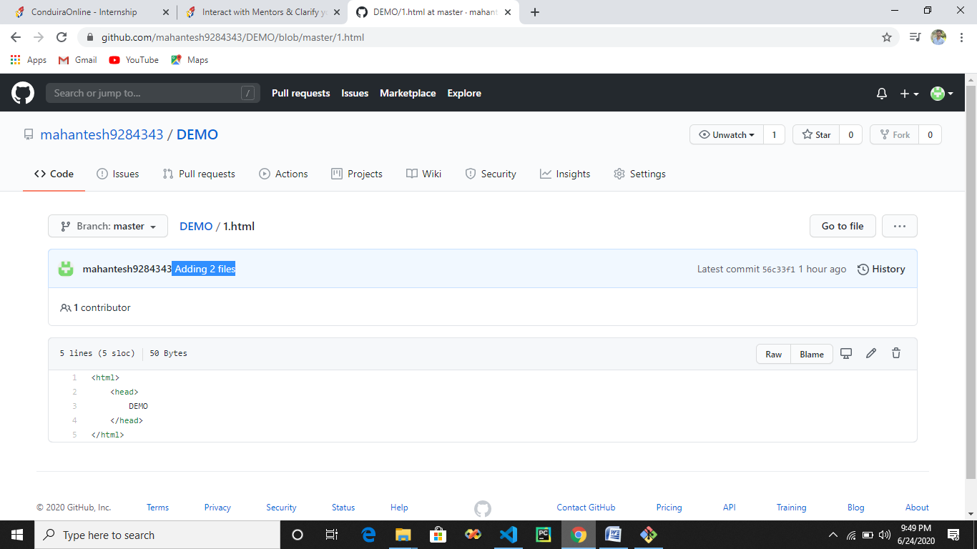

* **We can see that we have commit message as Adding 2 files , these message can be use to edit code in particular file for which we have commit message also.**
* **Commit message should contain the functionality what the file is doing so that we can understand what function does the file has.**

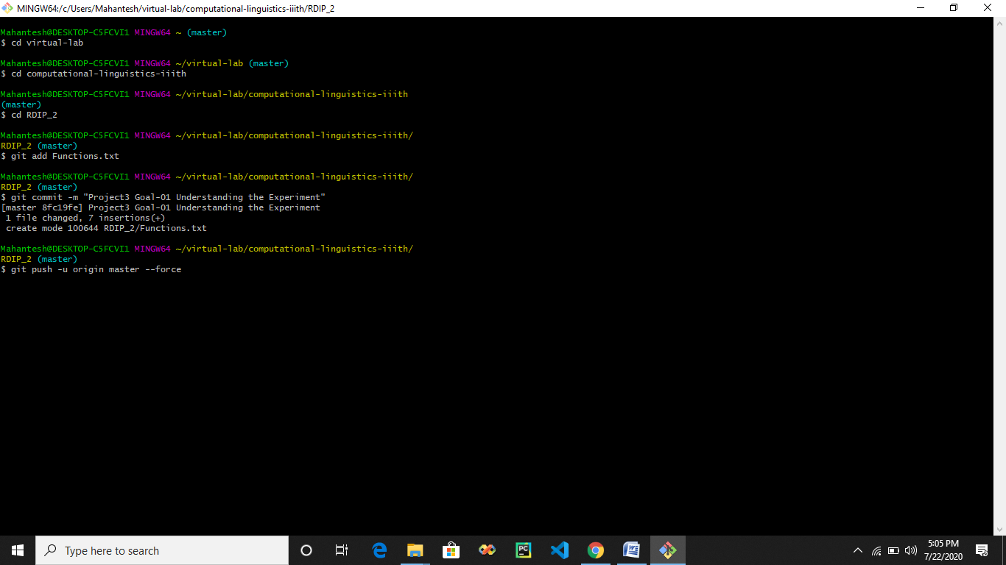

**#] Where do we find commit ID**

**Open repo 🡪 Click on commit option 🡪 Click on commit message 🡪 Right side commit ID**

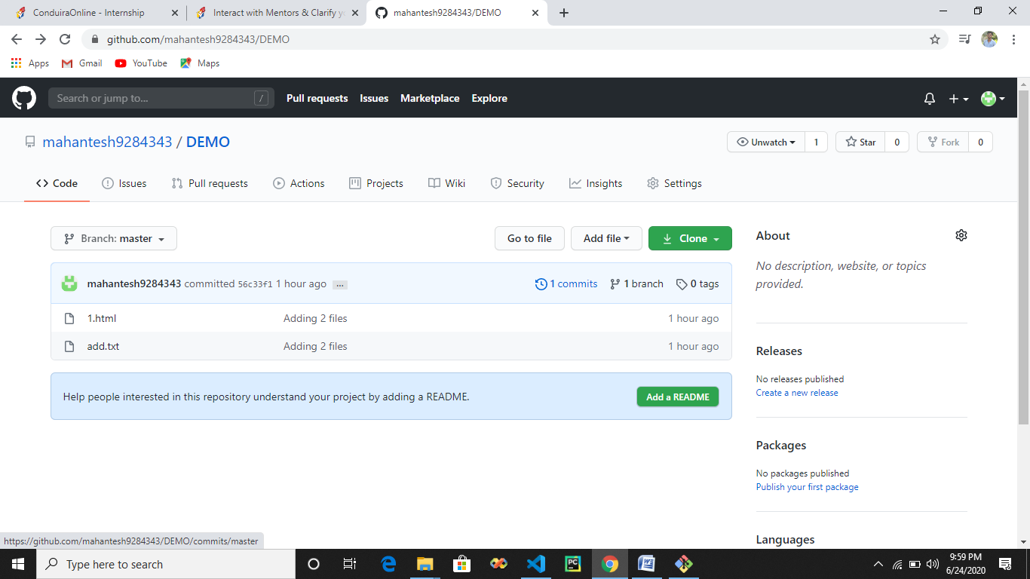

* **Click on commits on menu bar**

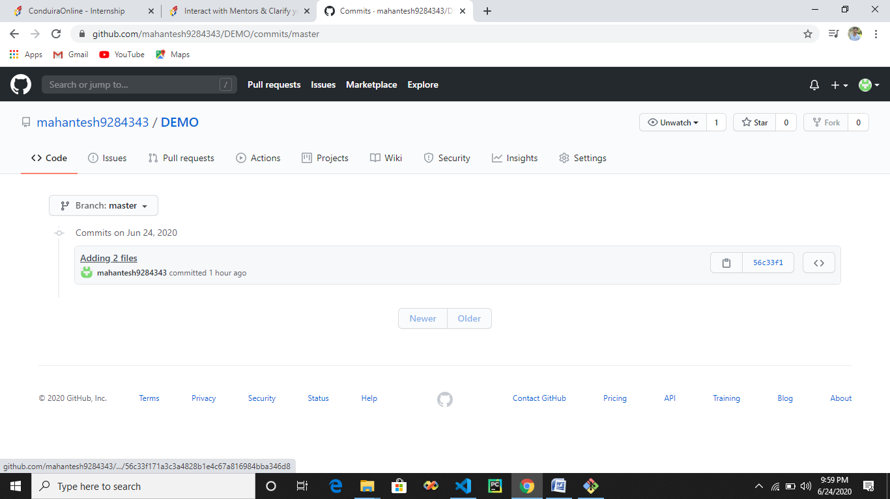

* **Click on commit message ie Adding 2 files**

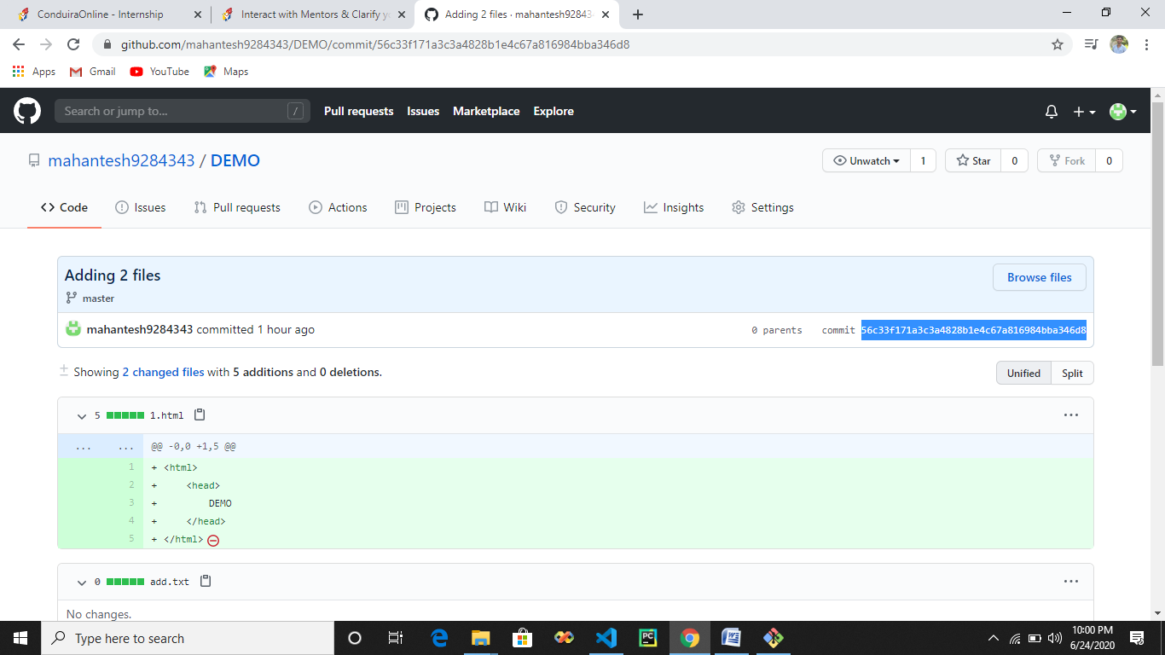

* **Here you can see commit ID**

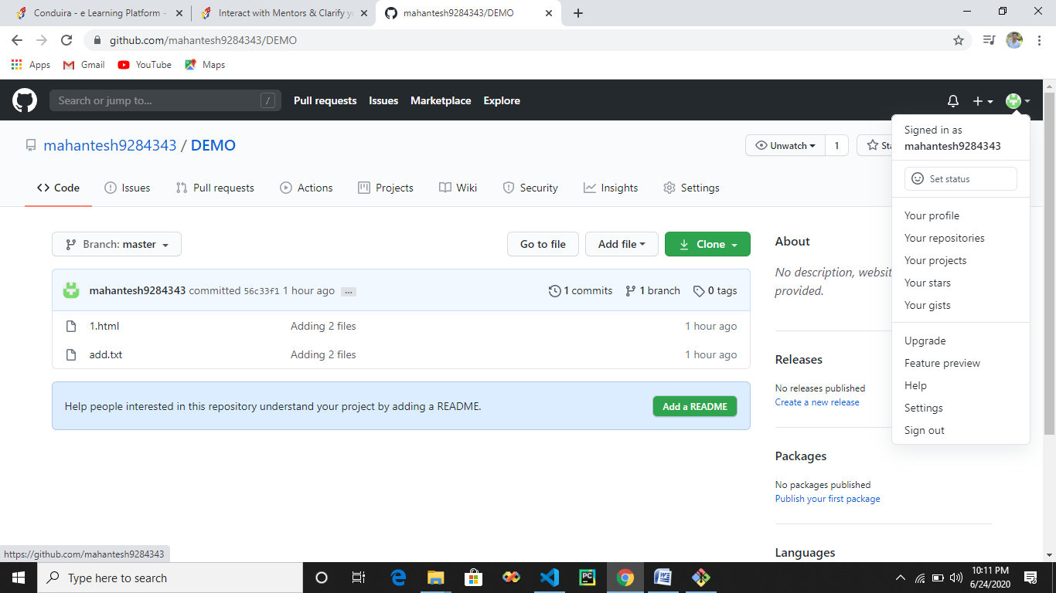

* **Here we can see that whatever is written in signed in as is our github handle**

**#] Now I will create new file in my main repo by goint to option 🡪 Add file 🡪 Create new file**

**(These is not good option to create file , we should do it from git bash)**

* **So now my repo has 3 files**

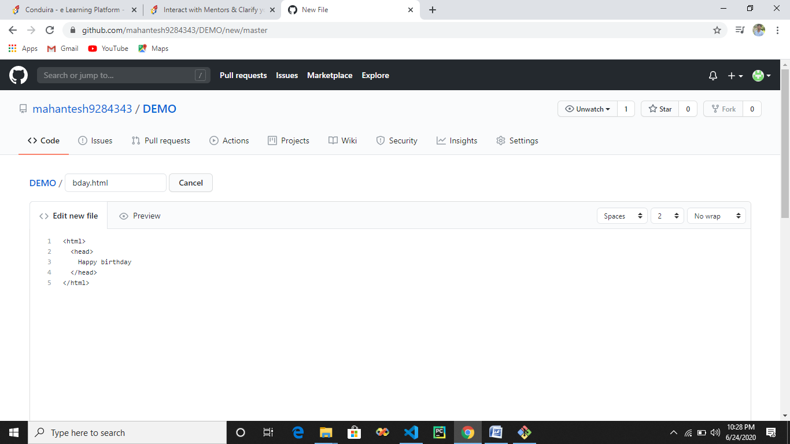

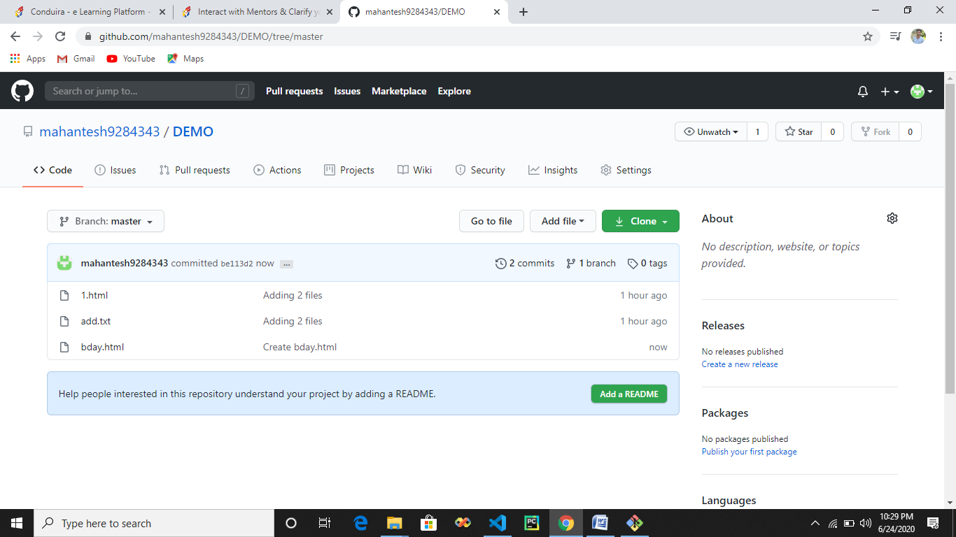

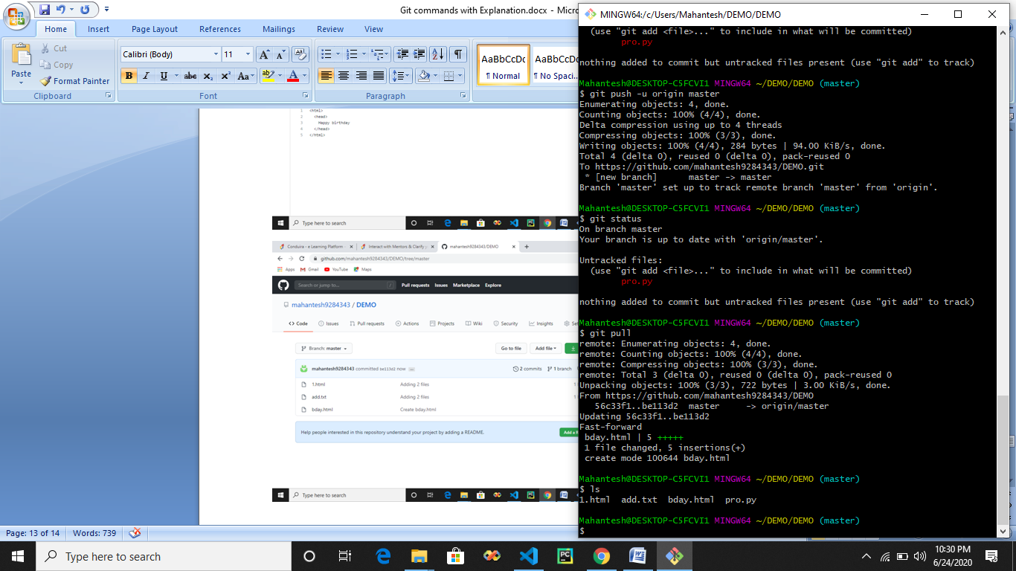

* **Git pull will pull files from main repo to local repo as a copy , both main and local repo will contain same files**
* **ls will show updated local repo files it contains.**
* **It is ok to contain the files in local repo but not in main github repo, but the files which are present in main github repo should be present in local repo/directry/machine.**

**That’s why we use pull to update our local repo**

**#] Forking : Forking is basically coping all the contents from other repository to my main github repository.**

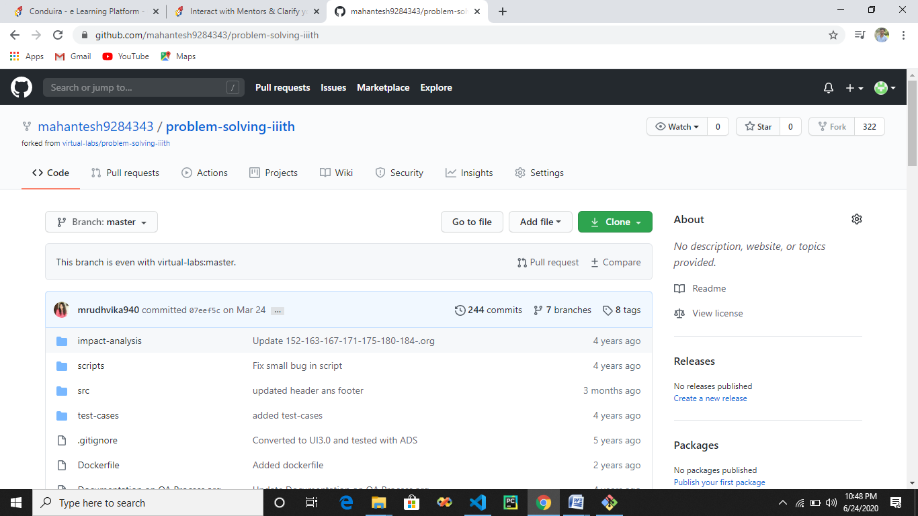

* **Here we can see that we went to some others repo and clicked on fork(upper right corner) so all files from forked repo will come in our main github repo.**
* **Now I wll click on clone(green button) , copy the ID**

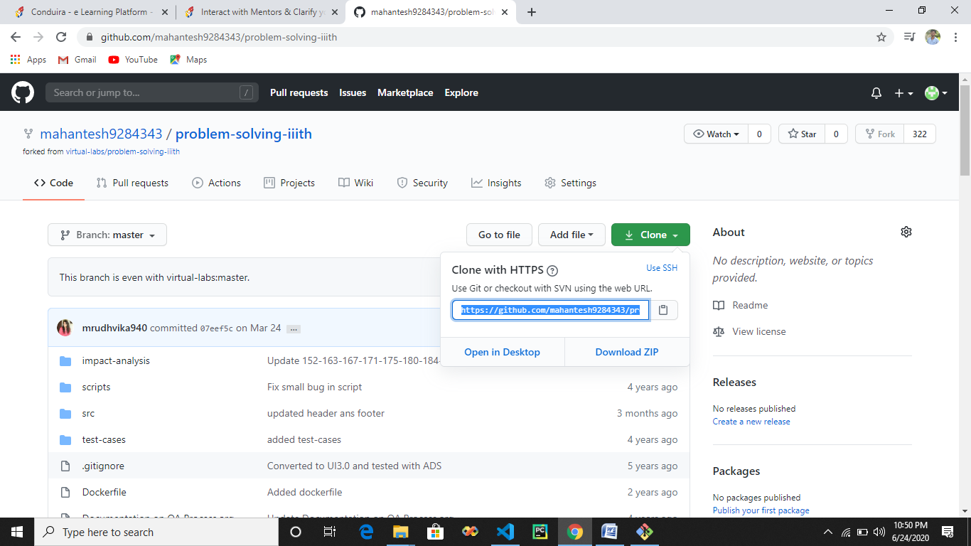

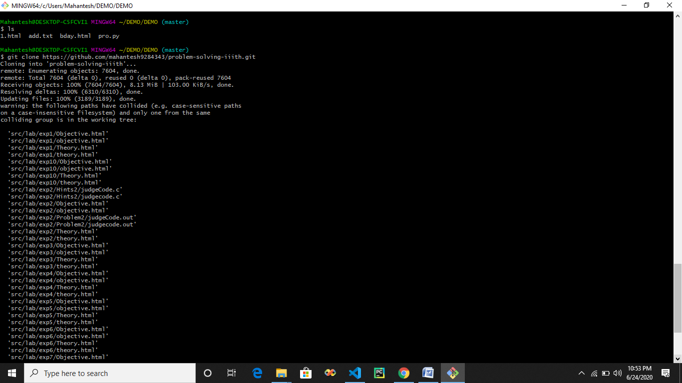

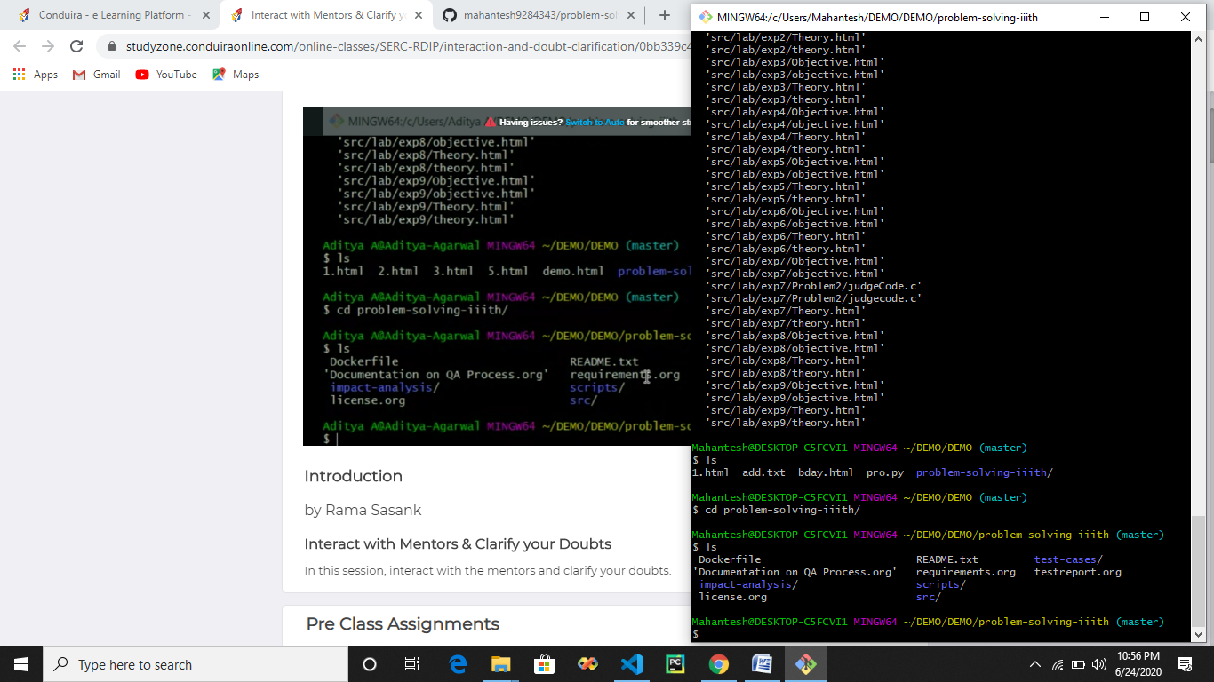

* **Here we can see that I have cloned the forked data into my local machine**
* **My local machine will contain all the data which I forked.**
* **ls show me all files in local directory**
* **I changed my directory to problem-solving-iiith/ to see filee**
* **Again ls show me all files in problem-soling-iiith/**

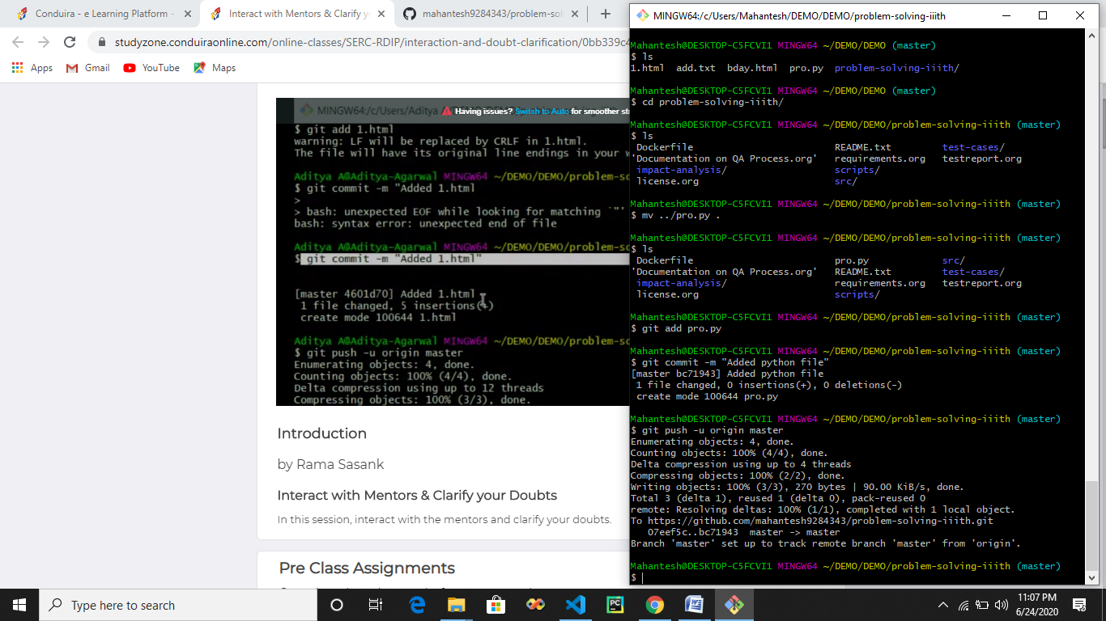

* **Here we can see that I have moved file into problem-solving-iiith/**
* **I checked in list of files in problem-solving-iiith/**
* **I added that file to mu main github repo**

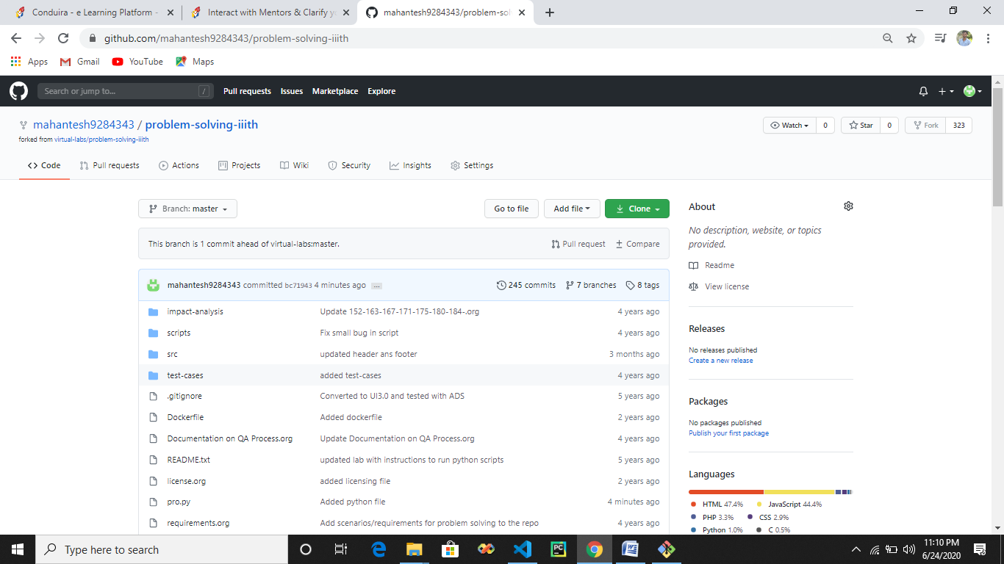

* **Here we can see that pro.py came in problem-solving-iiith/**

**#] Pull request :- It is use to tell virtual labs that particular repo that I have made a change by adding new file for these pull request is used.**

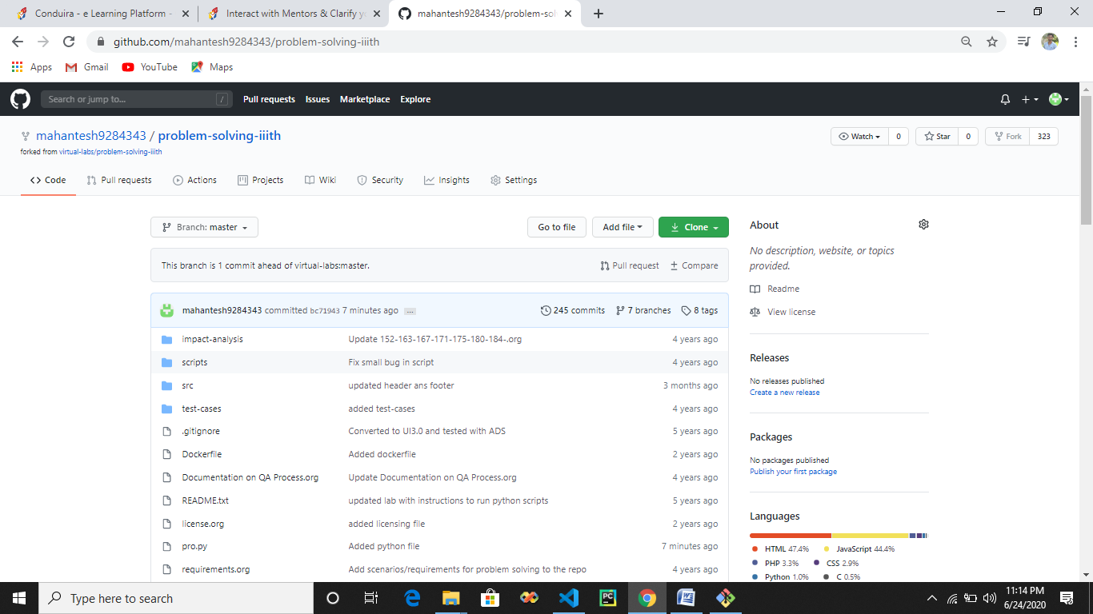

* **Click on pull request 🡪 new pull request.**

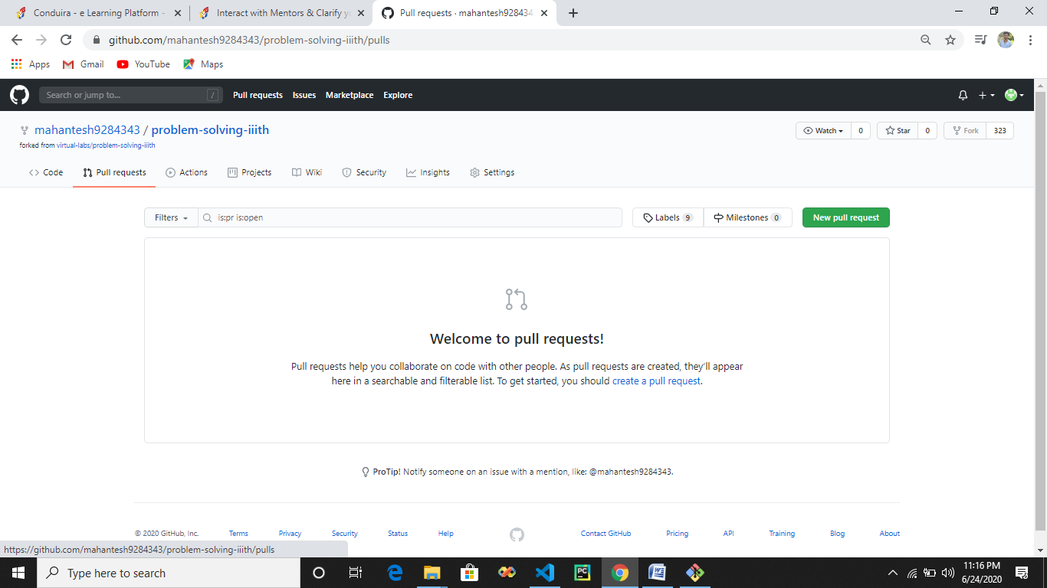

* **Click on create pull request🡪**

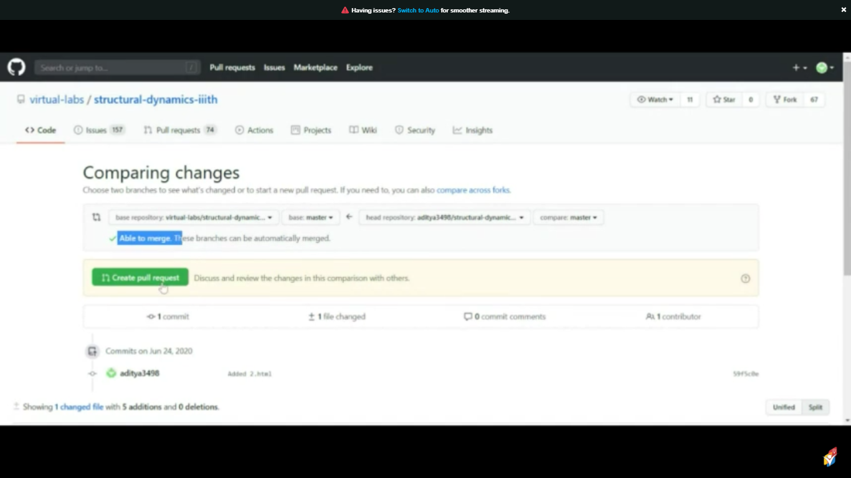

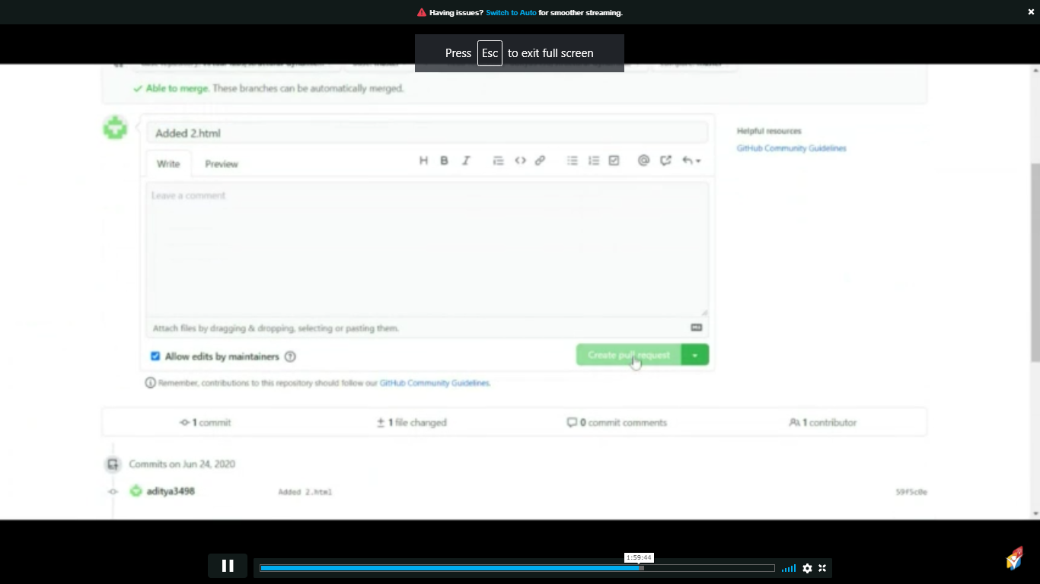

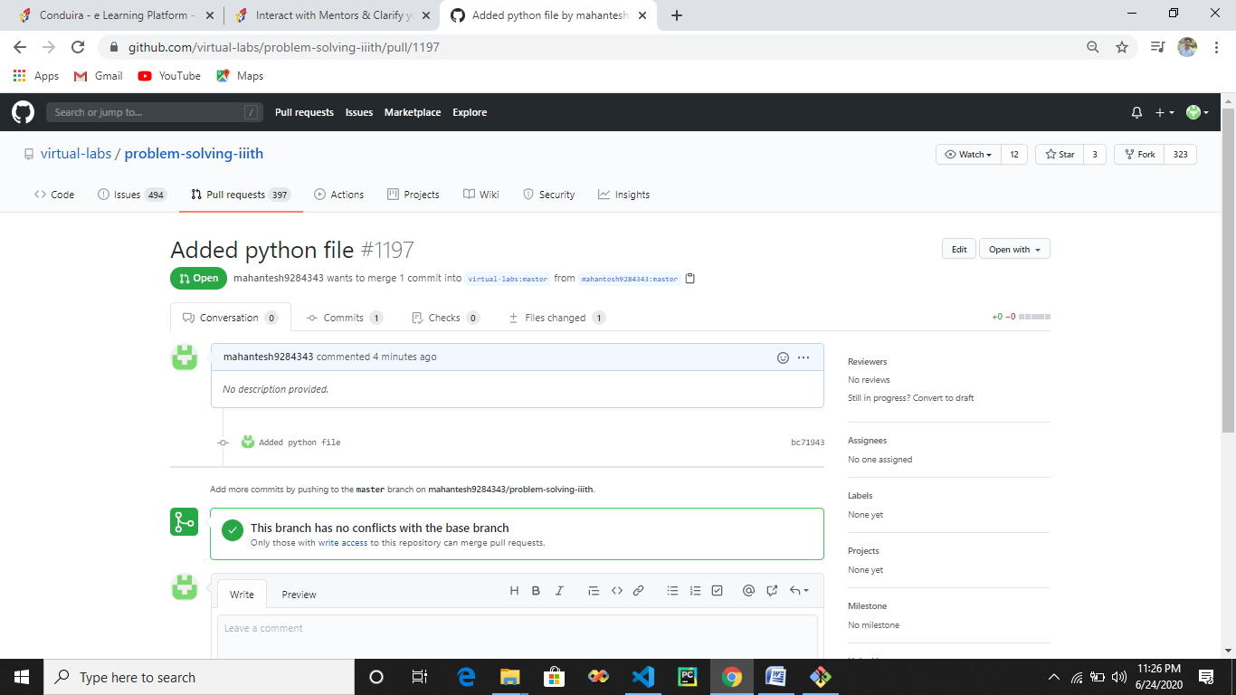

* **Here we can see pull request is done now the admin of virtual lab will get request to merge the request which we have made by adding new file to the problem-solving-iiith/**